BEFORE THE IDAHO PUBLIC UTILITIES COMMISSION
Office of the Secretary
Service Date
March 13, 2023

IN THE MATTER OF FALLS WATER CO., INC.’S APPLICATION FOR DEFERRAL OF CERTAIN COSTS | )  )  )  )  )  )  ) | CASE NO. FLS-W-22-01  ORDER NO. 35706

On October 31, 2022, Falls Water Co., Inc. (“Falls Water” or “Company”) filed an application (“Application”) with the Idaho Public Utilities Commission (“Commission”) requesting authorization to defer costs associated with groundwater mitigation so that Falls Water might advocate for the recovery of those costs in a future rate case.
Falls Water is a regulated water company that serves approximately 6,400 customers within its service territory near Idaho Falls, Idaho, pursuant to Certificate of Public Convenience and Necessity No. 236, and owns certain water rights under which Falls Water is allowed to pump groundwater from its wells to serve its customers. Falls Water is located within the Bonneville-Jefferson Ground Water District (“District”), which is a member of an entity known as the Idaho Ground Water Appropriators, Inc. (“IGWA”).
In 2016, IGWA entered into a Stipulated Mitigation Plan (“Mitigation Plan”) with an entity known as the Surface Water Coalition (“SWC”). The Mitigation Plan provided a framework for administrating groundwater rights, including Falls Water’s groundwater rights, in a manner designed to decrease conflict between water users. As a result of the Mitigation Plan, groundwater users within the District were required to decrease groundwater production by approximately 18,000 acre-feet. The Company stated that in 2022, the cumulative growth on the system, drought conditions, and the actions of other members of the District were such that incurring mitigation fees was necessary for Falls Water to pump sufficient water to meet customer demand. The Company does not know the precise amount of mitigation fees, but the Company expects the fees to be material considering Falls Water’s overall operations.

STAFF COMMENTS
Commission Staff (“Staff”) reviewed the Company’s Application, supporting documents, responses to Production Requests, and the proposed accounting treatment. Staff believed the Company’s request was reasonable based on the extraordinary circumstances of the special assessment fees. Staff considered: (1) customer growth; (2) the Company’s mitigation efforts; (3) the breach of the Mitigation Plan and its potential to impact the Company; (4) the cost of mitigation; and (5) the estimated cost to the Company’s customers.
Staff noted that on a case-by-case basis, the Commission has generally allowed deferred accounting treatment for extraordinary and unusual expenses mandated by a regulatory or similar authority that have a significant financial impact on the Company. Staff believed the groundwater mitigation expenses fell into that category as the District had mandated those costs through the Mitigation Plan implementation. Staff reasoned that the Company had yet to encounter these types of expenses before the current circumstance, and the Company does not know if those expenses will continue to occur, or the timing and amount of additional groundwater mitigation costs. Thus, Staff believed that those costs were extraordinary and unusual in nature. However, Staff reasoned that if groundwater mitigation costs become a routine annual expense, prudent mitigation costs should be included in customer rates in the Company’s next general rate case.
Staff recommended the Commission approve the Company’s Application to defer costs associated with mitigation and fees assessed by the District into a regulatory asset account until its next general rate case. At that time, the prudence of the expenses incurred, and the recovery method, would be determined. Additionally, Staff recommended that the Company keep its customers apprised of the potential change in rates resulting from future groundwater mitigation efforts and inform customers of the part that customers with over-zealous watering habits play in the delicate balance between water usage and overall customer rates.
COMPANY COMMENTS
The Company appreciated Staff’s review of the Application and agreed with Staff’s recommendations. The Company recognized that the issues presented in the Application require ongoing, proactive attention, and that these sorts of issues may become more acute as the population grows and water supply may remain stable or even decline. The Company appreciated deferral treatment of the identified costs and represented that it would remain in contact with the Commission and Commission Staff as the situation evolved and as different solutions presented themselves.
COMMISSION FINDINGS AND DECISION
The Commission has jurisdiction over the Company’s Application and the issues in this case under Title 61 of the Idaho Code including Idaho Code §§ 61-301 through 303. The Commission is empowered to investigate rates, charges, rules, regulations, practices, and contracts of all public utilities and to determine whether they are just, reasonable, preferential, discriminatory, or in violation of any provisions of law, and to fix the same by order. Idaho Code §§ 61-501 through 503.
The Commission has reviewed the Company’s Application, all submitted materials, and comments of the parties. Based on its review of the record, the Commission finds it fair, just, and reasonable to authorize the Company to defer, without interest, the special assessment fees and other costs associated with groundwater mitigation into a regulatory asset account, with recovery subject to a prudency review in its next general rate case.
The Commission notes that these issues regarding fees and special assessments require more transparency between the Company and its customers. The Company is directed to provide more transparency to its customers over the special assessment and the potential impact it may have on rates. The Company is similarly directed to update the Commission when the District has determined how the breach of Mitigation Plan will impact the Company. Finally, the Company is directed to both continue, and expand, all reasonable mitigation efforts.
ORDER
IT IS HEREBY ORDERED that the Company is authorized to defer, without interest, the special assessment fees and other costs associated with groundwater mitigation into a regulatory asset account, with recovery subject to a prudency review in its next general rate case.
IT IS FURTHER ORDERED that the Company shall provide more transparency between the Company and its customers over the special assessment and the potential impact it may have on rates.
IT IS FURTHER ORDERED that the Company shall update the Commission when the District has determined how the breach of Mitigation Plan will impact the Company.
IT IS FURTHER ORDERED that the Company shall continue, and expand, all reasonable mitigation efforts.
THIS IS A FINAL ORDER. Any person interested in this Order may petition for reconsideration within twenty-one (21) days of the service date upon this Order regarding any matter decided in this Order. Within seven (7) days after any person has petitioned for reconsideration, any other person may cross-petition for reconsideration. Idaho Code §§ 61-626 and 62-619.
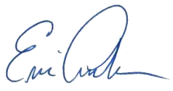
DONE by Order of the Idaho Public Utilities Commission at Boise, Idaho this 13th day of March 2023.

ERIC ANDERSON, PRESIDENT

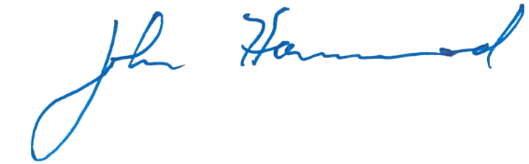

JOHN R. HAMMOND JR., COMMISSIONER
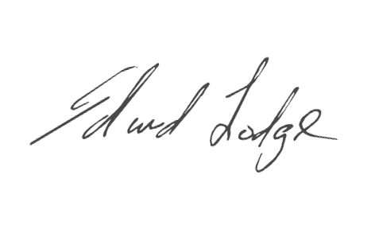

EDWARD LODGE, COMMISSIONER
ATTEST:

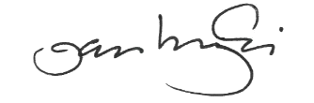

Jan Noriyuki
Commission Secretary

I:\Legal\WATER\FLS-W-22-01 GW Mitigation\orders\FLSW2201_final_cb.docx

